# **Section 19.4: The Final Journey – Phase 4: The Last Vassa at Beluwa and Road to Kusinara**

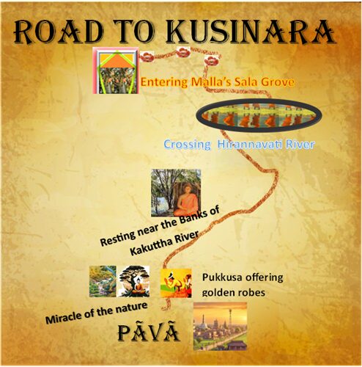

## The Last Vassa at Beluva: A Season of Strength, Compassion, and Farewell

The sacred texts recount with deep solemnity:

*“And when the Lord had stayed at Ambapālī′s grove as long as he wished, he departed with a large company of monks to a small village named Beluva, where he stayed. There he said to the monks:*

*‘Go now, each of you, to where you have friends or supporters in Vesālī and spend the rains retreat there. I shall remain here in Beluva.’ ‘Very good, Lord,’ they replied. And so it was that the Blessed One spent the rains at Beluva, attended only by Venerable Ānanda.”*

This tiny village—*Beluva* (also referred to as *Veluva* in the ancient texts)—was once part of the Vajji country near Vesālī, though its exact location is no longer known on modern maps. Yet, in the luminous annals of the Dhamma, Beluva stands eternal, bathed in the quiet radiance of the Buddha’s final rains retreat.[1]

### A Season of Silence and Strength

It was during this retreat, in the peaceful solitude of Beluva, that the Buddha fell gravely ill. The scriptures describe the episode with great poignancy:

*“He was attacked by a severe sickness, with sharp pains as if he were about to die. Yet the Blessed One endured all with mindfulness, with clear comprehension, without complaint.”*

Even in the grip of intense pain, his heart remained unshaken. The Blessed One, ever mindful of his responsibility to the Sangha, thought to himself:[2]

*“It would not be fitting for me to attain final Nibbāna without first addressing the order of monks. I must restrain this illness by energy and determination.”*

And so, he held his illness at bay through sheer resolve—not out of fear, not from clinging to life, but out of his boundless compassion for his disciples.

### Venerable Ānanda’s Grief and the Buddha’s Great Teaching

As soon as the Buddha felt some relief, he came out and sat quietly on a prepared seat outside his dwelling. Venerable Ānanda, deeply shaken by the sight of his beloved Master’s suffering, approached him and said:

*“Lord, I have seen your patience, your serene endurance. Yet my own body felt like that of a drunkard. I lost my bearings. Things were unclear to me. The only comfort I found was this thought: ‘Surely, the Lord will not attain final Nibbāna until he has given some instruction to the Sangha.’”*

The Blessed One responded with a deep truth:

*“Ānanda, what does the order expect of me? I have held nothing back. There is no ‘teacher’s fist’ in the Tathāgata. I have taught the Dhamma openly, without inner or outer distinctions.”*

And then, with great gentleness and clarity, he declared that **the Dhamma itself must now be the refuge:**

*“Ānanda, be an island unto yourselves, a refuge unto yourselves, with no other refuge. Let the Dhamma be your island, the Dhamma your refuge. Abide, contemplating the body as body… feelings as feelings… mind as mind… and mind-objects as mind-objects, clearly aware, mindful, having put away all longing and sorrow for the world.”*

*“Those who now, or after I am gone, live thus—desiring to learn and grow—they shall reach the highest.”*

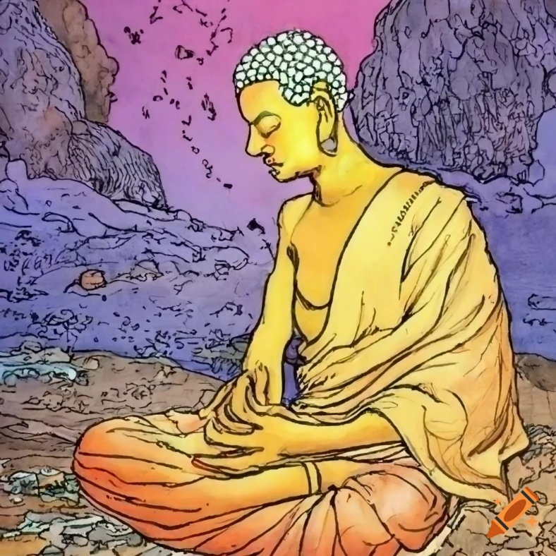

**The Buddha after his sickness at Beluva.[3]**

### Beluva: A Sacred Turning Point

The gentle forest groves of Beluva thus became the setting for one of the most touching moments in the Buddha’s life. It was a place of profound teaching, intimate farewell, and noble endurance. There, the Blessed One—aged, worn, held together like an old cart—shone all the more brightly in his silent strength and unwavering compassion.

In Venerable Anuruddha’s words from the *Theragāthā*, this village remains blessed:

*“In the Vajjian village of Veḷuva,  
At the end of life,  
Beneath a thicket of bamboos,  
I’ll realise nibbāna without defilements.”* .[4]

Let us remember Beluva not merely as a forgotten village, but as a sanctuary where the light of the Dhamma was passed with love, wisdom, and boundless grace from teacher to disciples—before the Blessed One continued on his final journey toward Parinibbāna.

## The Blessed One’s Decision to Attain *Parinibbāna*

As the vassa season approached, the Blessed One had reached his eightieth year. Born on the full moon day of Vesākha, he entered the rains retreat—*vassa*—on the full moon of Āsāḷha. With his body aging and his strength waning, the Buddha had long foreseen the natural limitations of physical form. It appears that even when he began his final journey from Sāvatthī, he was already aware that his life was drawing to its close. Now, with equanimity and wisdom, he began to make preparations for his final departure.

### At the Cāpāla Shrine

Having recovered from a severe illness, the Buddha once again went on alms round in the city of Vesālī. After his meal, he addressed the Venerable Ānanda:

“Bring a mat, Ānanda. Let us go to the Cāpāla Shrine for the siesta.”[5]

There, seated in quiet dignity, the Blessed One gazed upon Vesālī and its many shrines—Udena, Gotamaka, Sattambaka, Bahuputta, and Sārandada. He spoke fondly of these places where he had previously spent peaceful times in meditation.

Then the Buddha said:

“Ānanda, one who has fully developed and mastered the four bases of spiritual power—if he so wishes—can remain for a century, or the remainder of one. The Tathāgata has developed and cultivated these powers… and could do so as well.”

But Ānanda, in that moment, did not comprehend the gentle yet profound invitation hidden in these words. He did not entreat the Blessed One to remain, to extend his life for the benefit and happiness of devas and humans.

The Blessed One, out of his compassion, gave Ānanda this opportunity—but he, overwhelmed perhaps by routine or unawareness, did not seize it. However, as students of the Dhamma, we understand that the Tathāgata, perfectly awakened, was not bound by longing to remain, nor swayed by worldly ties. He had already transcended attachment to form, to time, to the world. As such, he remained only for the sake of the Dhamma and the benefit of beings.

Then the Buddha said gently:

“Go now, Ānanda, and do as you see fit.”

### Māra’s Final Visit

Soon after Ānanda had left, Māra, the Evil One, approached the Blessed One and said:

“Lord, now is the time for your final Nibbāna. You once declared that you would not attain final Nibbāna until your disciples were well-trained, capable, and ready to preserve the Dhamma. (See Section 4 and 4-1) That time has come. Let the Blessed One now attain final Nibbāna.”

And the Buddha replied:

“Do not worry, Evil One. The Tathāgata’s final passing will not be long delayed. Three months from now, the Tathāgata will attain *Parinibbāna*.”

There, at the Cāpāla Shrine, mindful and clearly aware, the Buddha made the momentous decision: he renounced the life-principle. And at that very instant, the earth itself trembled in a great quake—vast, awe-inspiring, and thunderous. The Blessed One then uttered these words:

“What causes life, unbounded or confined — His process of becoming

—this the Sage Renounces. With inward calm and joy, he breaks,

As though a coat of mail, his own life’s cause. [6]

It is said that the earth trembled because she could not bear the sorrow of losing the Greatest of the Great appeared in this earth.

### Ānanda’s Grief and the Teaching on Impermanence

Not far away, Ānanda too witnessed the earthquake. Alarmed and awestruck, he approached the Blessed One and inquired about its cause. The Buddha explained that there are eight reasons for a great earthquake, one of which is when a Tathāgata, mindful and fully aware, renounces the life-principle.

The Buddha then revealed to Ānanda the encounter with Māra and his decision to pass away in three months' time.

Shaken with sorrow and love, Ānanda finally made his heartfelt plea:

“Lord, may the Blessed One stay for a century, may the Well-Farer remain for the benefit and happiness of the multitude, out of compassion for the world…”

But it was no longer the time. The Buddha replied:

“Enough, Ānanda. Do not ask the Tathāgata. It is not possible now.”

Three times Ānanda made his request, and each time the Blessed One, gently but firmly, reminded him:

“**Have you not heard me say: All things dear and pleasing to us must undergo change, separation, and alteration? Whatever is born, becomes, and is compounded, is bound to decay. That it should not decay—this is not possible.”**

Then the Buddha spoke directly to Ānanda’s heart:

“Ānanda, the Tathāgata has made his decision. He will not reverse it. That which is given up has been given up once for all. The Tathāgata has renounced the life-principle. *Parinibbāna* will occur in three months' time.”

### Reflections

In this sacred moment, the Buddha reaffirms the central truth of his teaching: **impermanence** (*aniccā*). Not even the body of a Tathāgata is exempt from dissolution. With complete serenity, compassion, and clarity, the Blessed One chose to let go, not because he was weary, but because the Dhamma had been well established, the Sangha well trained, and the time was ripe.

May we, in contemplating this passage, grow in understanding of the Dhamma—not through sorrow, but through deep inspiration, recognizing the perfect wisdom and boundless compassion with which the Buddha guided the world.

### The Blessed One’s Announcement to the Sangha

Then the Blessed One said to the Venerable Ānanda,  
“Ānanda, summon all the monks residing in and around Vesālī to gather in the Gabled Hall in the Great Forest.”[7]

When the Sangha had assembled and sat in silent anticipation, the Buddha—moved by boundless compassion and ever-mindful of the welfare of his disciples—addressed them with words that would echo through the ages:

**“Monks, I now declare to you:  
All conditioned things are subject to decay.  
Strive on with diligence.  
The Tathāgata’s final passing will not be long delayed.  
Three months from now, the Tathāgata will attain final Nibbāna.”**

Then the Blessed One added, with calm and clarity:

**“Ripe am I in years, my life’s course has run,  
Now I go from you, having made the Dhamma my refuge.  
Monks, be earnest, be mindful, be disciplined,  
Guard your minds with collected awareness.  
Whoever tirelessly follows the Dhamma and the Discipline,  
Shall leave the round of birth and bring suffering to an end.”**

Though the sutta records no outward response from the assembled monks, one can imagine the depth of feeling that stirred in the hearts of those present. The Arahants, established in equanimity, would have received the news in silence and serenity, honouring the natural law of impermanence. Yet those who had not yet reached the final goal—the stream-enterers, once-returners, non-returners—may have felt a wave of inner tremor, knowing that their sublime Teacher would soon depart forever from their sight.

As for the many who were still walking the path, devoted yet unenlightened, the announcement must have been like a thunderclap—stunning, sorrowful, but borne in noble silence, out of deep respect for the Blessed One.

And indeed, later—at the final moment—when the Buddha’s last breath passed gently away beneath the Sāla trees, even the great Venerable Ānanda, so long by his side, wept as a child might grieve the loss of a beloved father.

Even today, more than 2,600 years since the Parinibbāna of the Blessed One, the tender echoes of those final words move our hearts. We read them, we listen, and tears rise—not merely of sorrow, but of boundless gratitude for a Teacher who gave all, held nothing back, and pointed the way out of all suffering.

May the Great Hall of Vesālī still carry the vibrations of that sacred moment.  
May it whisper even now:  
**“All conditioned things are impermanent—strive on with diligence.”**

**Diligence**

A monastic who delights in heedfulness, seeing danger in heedlessness,

advances like burning fire against the fetter, small or large.

*Appamādarato bhikkhu, pamāde bhayadassivā,  
saṁyojanaṁ aṇuṁ-thūlaṁ ḍahaṁ aggīva gacchati.*

monastic who delights in heedfulness, seeing danger in heedlessness,

is unable to fall away:  he is well-nigh to Nibbāna.

*Appamādarato bhikkhu, pamāde bhayadassivā,  
Aabhabbo parihānāya: Nibbānasseva santike. [8]*

## Walking Towards Kusinara

We now turn our attention to the final leg of the Blessed One’s journey—his departure from Vesāli and gradual progress toward Kusinārā. According to tradition, the Buddha spent his 44th vassa at Jetavana Monastery in Sāvatthi. As noted earlier in Section 19-1:

“According to tradition, after completing his 44th rainy retreat at Jetavana Monastery, the Buddha, accompanied by a large number of bhikkhus, departed from Sāvatthi and began his journey toward Rājagaha. During the Buddha’s time, the rainy season retreat (vassa) typically began on the Āsāḷha full moon day (June/July) and lasted three to four months, ending around the Kattika full moon day (October/November). Based on this timeline, we can assume that he left Sāvatthi around mid-November.”

Continuing from this, the Buddha spent his 45th and final vassa in Beluva near Vesāli, at the age of 80. Assuming a similar calendar, the vassa would have ended around mid-November. It was during this period in Beluva that he fell gravely ill, and it is reasonable to assume that some time was needed for partial recovery before he resumed his journey.

It was in Vesāli, after recovering, that the Buddha made his solemn declaration to Ānanda that he would attain final Nibbāna three months from that point. Placing this event in late February or early March (Phagguṇa) aligns well with the traditional account of his Parinibbāna occurring on the full moon of Vesākha (mid-May). (see the calendar given below). [9]

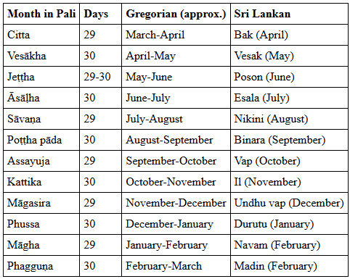

### 

From Vesāli to Kusinārā, the modern distance is approximately 216 kilometres (see the map below) . Given the nature of ancient travel—walking with a group of bhikkhus, teaching along the way, and sometimes pausing at monasteries or villages—it is reasonable to estimate a journey of 4 to 5 weeks. This timeline allows for a steady pace and aligns with his declaration of Parinibbāna occurring three months after his announcement in Vesāli.

Thus, we can tentatively place his departure from Vesāli in early to mid-March (Phagguṇa), leading toward his final passing in Kusinārā under the Sala trees in mid-May (Vesak full moon day)

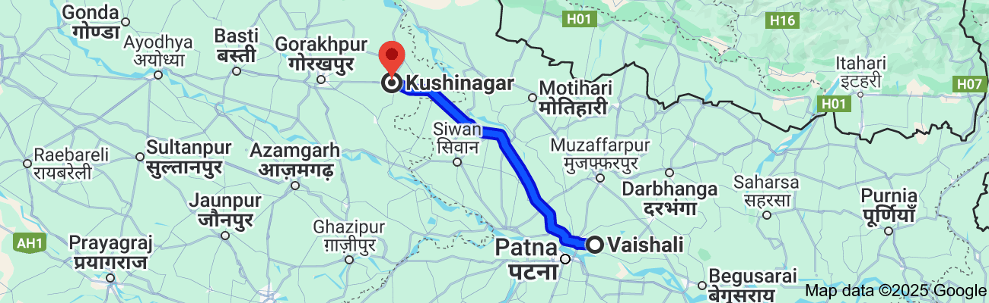

**Modern day road map of Vaishali, Bihar to Kushinagar in UP, distance 216 km [10]**

## Farewell to Vesālī and the Arrival at Bhāṇḍagāma

The time had come for the Blessed One to take leave of Vesālī. The scriptures poignantly preserve his final words upon departing the beloved city:

*“Ānanda, this is the last time the Tathāgata will look upon Vesālī. Now we shall go to Bhāṇḍagāma.”[11]*

With serene mindfulness and great compassion, the Blessed One then set out with a large community of monks, journeying northward to Bhāṇḍagāma, where he rested and offered profound teachings.

### Bhāṇḍagāma — A Village in the Vajjian Country

Though the precise location of Bhāṇḍagāma is not marked on modern maps of India, traditional accounts place it as a Vajjian village nestled between Vesālī and Hatthigāma—likely closer to Vesālī. Based on the current road distance from Vesālī to Pāvā (identified with present-day Fazilnagar or Pawanagar), which is about 197 km, it is reasonable to estimate that Bhāṇḍagāma lay approximately 65 km northwest of Vesālī. The next stop, Hatthigāma, may have been a further 65–70 km from there, fitting the gradual rhythm of the Buddha’s final journey. (see the map below)

Interestingly, the name *Bhāṇḍa* (भाण्ड) means “merchandise” in Sanskrit, suggesting this may once have been a bustling trade village—perhaps part of an ancient commercial route connecting Vesālī, Pāvā, and Kusinārā. The presence of such a village along the Buddha’s final path adds historical texture to the journey: the Dhamma was moving along the arteries of civilization, reaching even places where trade and transit thrived.

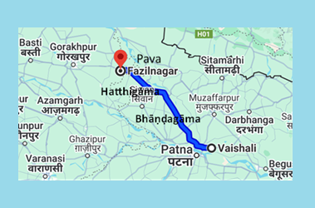

**Road from Vaishali via Bhandagama-Hattigama to Pava [12]**

### A Call to Liberation

Throughout his final journey from Rājagaha onwards, the Buddha continued to teach with unwavering urgency, especially addressing those disciples who had not yet realized the final goal. His message at Bhāṇḍagāma, preserved in the *Mahāparinibbāna Sutta*, is a powerful call to awakening:

“It is, monks, through not understanding and not penetrating four things that I, as well as you, have for a long time wandered through the cycle of rebirths. What are the four?  
Not understanding the Ariyan morality (sīla), the Ariyan concentration (samādhi), the Ariyan wisdom (paññā), and the Ariyan liberation (vimutti).  
By understanding and penetrating these four—morality, concentration, wisdom, and liberation—the craving for becoming is cut off, the tendency toward becoming is exhausted, and there is no more rebirth.”

Having spoken these words, the Blessed One added a verse, summarizing the path he had walked and offered to the world:

*“Morality, samādhi, wisdom and final release,*  
*These glorious truths the Sage, Gotama, came to know.*  
*The Dhamma he discerned, he taught his monks:*  
*He whose vision ended woe, to Nibbāna’s gone.”*

In these sublime teachings at Bhāṇḍagāma, we feel the compassionate urgency of the Buddha—urging his disciples not to delay, to penetrate the Dhamma here and now, and to walk the path of awakening before it is too late. This moment was not merely a pause in a physical journey—it was a gateway, a threshold, a final invitation into the timeless liberation he himself had realized.

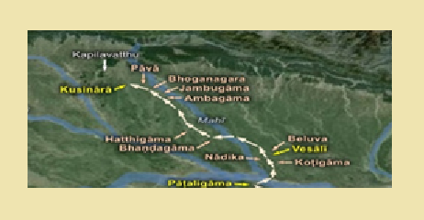

## Continuing the Sacred Journey: From Bhaṇḍagāma to Bhoganagara

After dwelling peacefully in Bhaṇḍagāma for as long as he wished, the Blessed One resumed his final journey, moving onward through a series of quiet villages—Hatthigāma, Ambagāma, Jambugāma—before reaching the resting place of Bhoganagara. These ancient sites, though no longer found on modern maps, once lay within the heartland of the Majjhimadesa (Middle Country), nestled between the sacred city of Vesālī and the Sal Grove of Kusinārā, where the Blessed One would soon attain Parinibbāna. A humble sketch of this sacred road is offered below. [13] (see the map given above).

**Hatthigāma:** This village, located on the path between Vesālī and Bhoganagara, belonged to the Vajji confederacy. It was the home of the devoted lay follower Ugga of Hatthigāma , also known as Ugga of Vesālī, who was praised by the Blessed One for his generosity toward the Sangha. The suttas recount how, after his passing, Ugga was reborn as a radiant deva who visited the Buddha and the monastic community (AN 8.21–22).

Long before his final journey, the Buddha had stayed in this village, and its people—deeply inspired by Ugga—were likely devoted practitioners of the Dhamma. It is not surprising, then, that the Blessed One chose to rest here once more, offering teachings for the benefit of the villagers and encouraging the Sangha to deepen their practice in morality (sīla), concentration (samādhi), and wisdom (paññā)—the three foundations that lead to Nibbāna.

**Ambagāma:** Tradition holds that Ambagāma was also part of the Vajji territory, situated north of Hatthigāma along the north–south route. The name suggests a land adorned with mango groves (amba meaning mango), evoking a serene rural beauty. While the Buddha may not have previously visited this place, its inclusion in the sacred itinerary of his final journey imbues it with quiet significance.

**Jambugāma:** Further north along the route lay Jambugāma, a village of the Malla kingdom near Kusinārā. Mentioned in the Mahāparinibbāna Sutta, its name likely derives from the rose apple trees (jambu) that flourished here. Even today, jambu trees remain abundant across northern India. The image of these trees may also stir memories of the young Prince Siddhattha meditating beneath a jambu tree in the royal park of Kapilavatthu—a moment of serene awakening that foreshadowed his great realization. (See Section 2)

**Bhoganagara:** This village marked the final resting point before the Buddha reached Pāvā. It holds deep scriptural significance. According to Aṅguttara Nikāya (AN 4.180) and Dīgha Nikāya (DN 16), it was here that the Blessed One instructed the Sangha on the Four Great References (Mahā-apadesa), guiding principles for evaluating the authenticity of any teaching.

Bhoganagara is also mentioned in the Sutta Nipāta (Snp 5), which recounts the journey of sixteen Brahmin students of Bāvarī as they sought the Buddha:

“Kosambī and Sāketa,

the supreme city Sāvatthī,

Setavya and Kapilavatthu,

and the city Kusinārā,

on to Pāvā and Bhoganagara,

to Vesālī, to the Māgadhan city (Rājagaha),

and to the Pāsāṇaka Cetiya,

delightful and charming.”

Though absent from modern geography, the reverence shown to Bhoganagara in scripture speaks to its spiritual stature. The teachings given here, especially the Four Great References, continue to illuminate the path for truth-seekers across generations.

Thus, the journey unfolds, each village a quiet witness to the Buddha’s final pilgrimage—a sacred trail where wisdom blossomed and the seeds of liberation were sown for the benefit of the world.

### The Four Great References: A Guiding Light in Bhoganagara

While dwelling in Bhoganagara near the Ānanda Shrine, the Blessed One offered a timeless teaching to the Sangha—a safeguard for the Dhamma, to preserve its purity for future generations. He spoke of **the Four Great References** (*Mahā-apadesa*)—principles by which one may discern the true word of the Buddha. [14]

“Bhikkhus,” said the Blessed One,  
“I will teach you the four great references. Listen well.”

1. **When a monk claims:** *“In the presence of the Blessed One I heard this: ‘This is the Dhamma, this is the discipline.’”*  
   One should neither accept nor reject it outright. Instead, reflect and **compare it with the Suttas and Vinaya**. If it aligns with them, it may be accepted as the word of the Buddha. If not, it must be set aside.
2. **When a statement comes from a Saṅgha** of elder and well-practiced monks:  
   Again, carefully examine it against the Suttas and Discipline. The truth is not determined by numbers or status, but by **harmony with the Dhamma and Vinaya**.
3. **When it comes from a group of learned elders**, skilled in the Dhamma and Discipline: The same careful discernment applies. The Dhamma is not to be followed by blind faith, but by wise reflection.
4. **When it comes from a single elder monk**, considered wise and experienced:  
   Even then, the standard remains the same—**match it with the scriptures**. If it is in line with the Blessed One’s word, it can be trusted. If not, it should be respectfully set aside.

“These, bhikkhus,” the Blessed One concluded, “are the four great references.”

Through these guiding principles, the Blessed One entrusted his followers with the **responsibility of preserving the Dhamma with wisdom and care**. It is not authority or tradition that determines truth, but fidelity to the actual teachings of the Enlightened One.

## Entering the City of Pāvā

When the Blessed One had remained in Bhoganagara for as long as he wished, he said to the devoted Ānanda:  
**"Ānanda, let us go to Pāvā."**  
"Very good, Lord," Ānanda replied. And so, with a great company of monks, the Lord journeyed on to Pāvā, where he stayed at the serene mango grove of Cunda the smith.[15]

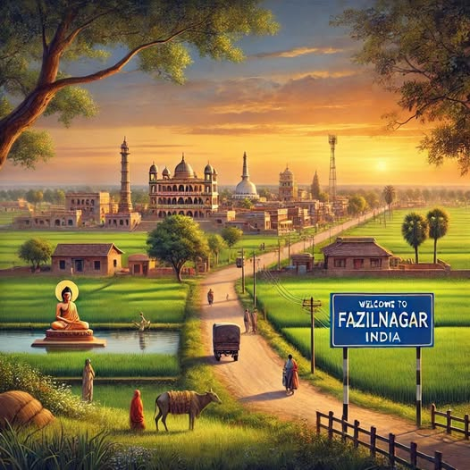

**An artist’s impression of Fazilnagar also known as Pawanagar (ancient Pāvā) [16]**

### Pāvā (Pawanagar)

A city of the Mallā people, Pāvā holds sacred significance in the final chapter of the Blessed One’s earthly life. Situated along the ancient Rajagaha–Vesālī trade route, Pāvā was not only a bustling centre of commerce but also a place of deep spiritual convergence, home to both Buddhists and Jains. It is recorded in the *Pasādika Sutta* (DN 29) and the *Upāli Sutta* (MN 56) that Nigaṇṭha Nāṭaputta, the leader of the Jains, passed away here—testifying to its importance as a spiritual crossroads.

Though its exact location remains uncertain, scholarly and archaeological research points to two likely sites: (see the maps below)[17]

* The area near modern-day **Fazilnagar** in Kushinagar district.
* A mound of ancient ruins known as **Jharmatiya**, in Chetiaon, also within the Kushinagar district.

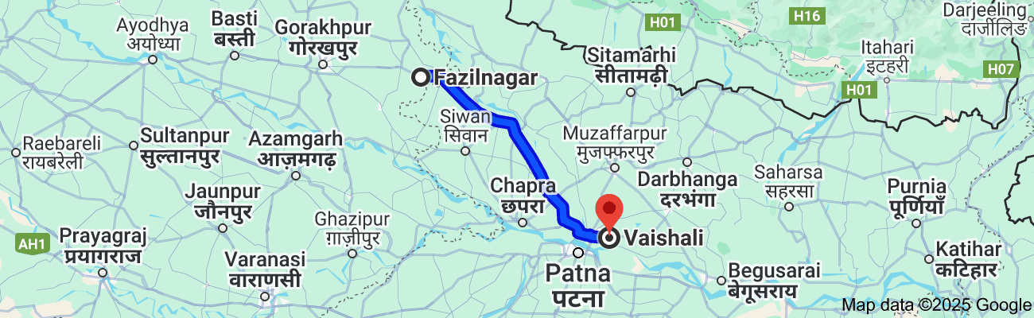

**Location of modern day Fazilnagar in UP** **(ancient Pāvā City of Mall Kingdom [18]** (Distance from Vesali, to Pāvā 197 km)

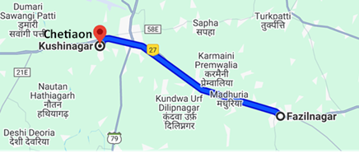

**Location of Chetian in Kushninagar (Kusinara),** Distance from Fazilnagar to Kushinara is 19 km

Archaeological discoveries include the remnants of a stupa believed to mark the site of Cunda’s residence—a devoted lay follower who plays a poignant role in the Buddha’s final journey. (see the picture below)

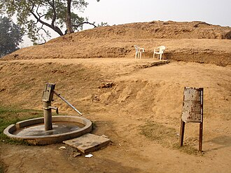

**A stupa built at the place where**[**Cunda's**](https://en.wikipedia.org/wiki/Cunda_Kamm%C4%81raputta)**house used to be, in ancient Pāvāv (present-day**[**Fazilnagar**](https://en.wikipedia.org/wiki/Fazilnagar)**)[19]**

### The Buddha’s Previous Visits to Pāvā

This was not the first time the Blessed One walked the streets of Pāvā. The scriptures preserve several earlier visits:

1. In *Udāna 1.7*, the Buddha is seen dwelling at the **Ajakalāpaka Tree Shrine** in Pāvā.
2. *Aṅguttara Nikāya 10.176* recounts a transformative meeting between the Buddha and Cunda, after which the smith became a devout follower.
3. *Dīgha Nikāya 33* mentions that the Mallas of Pāvā once invited the Buddha and his Sangha to reside in their newly constructed hall, **Ubbhaṭaka**—a sign of their respect and faith.

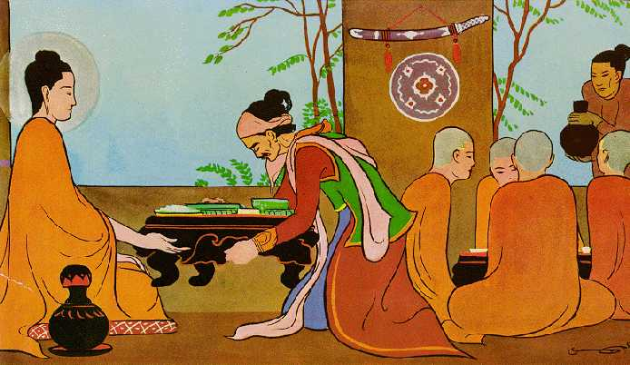

**Cunda offering the Final Meal to the Blessed One [20]**

### The Final Meal: Cunda’s Offering

When Cunda heard that the Blessed One had arrived in Pāvā and was staying in his mango grove, his heart overflowed with joy. He came to the Lord, paid homage, and listened with reverence as the Buddha offered him a sublime teaching of the Dhamma—uplifting, kindling, and illuminating.

Then Cunda, moved by deep devotion, invited the Buddha and the Sangha to receive a meal at his home the next day. The Blessed One accepted in silence—a noble consent—and Cunda, understanding the blessing of this moment, bowed and departed.

That night, Cunda lovingly prepared a meal of both soft and hard foods, including a dish known as **"pig’s delight."** [21] At dawn, the Buddha and the Sangha arrived. The Blessed One instructed:  
**“Serve the ‘pig’s delight’ to me, and the remaining food to the monks.”**

After the meal, he turned to Cunda and said with great clarity:  
**“Whatever is left of the ‘pig’s delight’ should be buried, for none in this world—be they devas, māras, Brahmās, or humans—could fully digest it, save for the Tathāgata.”**

Thus, he spoke. Then, once more, the Lord offered Dhamma to Cunda—wise, stirring, and filled with compassion—before rising and continuing his final journey.

### The Grave Illness

Later, at the First Council, Venerable Ānanda recalled the event thus:

**"After eating Cunda’s offering, the Blessed One fell gravely ill, struck by sharp, deadly pain. Yet, steady in mindfulness, he endured it with perfect patience."** [22]

Knowing the end was near, the Buddha, with boundless compassion, set his sights on **Kusinārā**—the destined place for his final Parinibbāna. He did not linger. There was no clinging, no delay. His heart was only with his disciples—guiding them, supporting them to awaken.

Throughout this final journey from Rājagaha, the Master stopped not to rest, but to **teach**, to **inspire**, and to **urge diligence**—ever mindful of impermanence, ever radiant in compassion.

### A Knowing Beyond Time

The Tathāgata had the wisdom to see across vast stretches of time—into past lives, into future destinies. Thus, he knew that **Kusinārā** would be the resting ground of his final body. And still, he walked on—not for himself, but for the liberation of others.

He later said:

**"Six times, Ānanda, I recall laying down the body in this place. The seventh time, I was a wheel-turning monarch, a righteous king. But now, I see no place in this world or among its gods where the Tathāgata shall lay down the body an eighth time."** [23]

Then the Teacher, serene and fearless, uttered this final truth:

**"Impermanent are all compounded things,  
Subject to rise and fall.  
Having arisen, they pass away—  
Their calm cessation is true bliss."**

### Gratitude of the Buddha

Even in his final hours, the Blessed One’s heart overflowed with **gratitude** and **gentle care**. Knowing that Cunda might blame himself for the Buddha’s passing, the Lord instructed Ānanda to offer these comforting words:

**“It is not by Cunda’s fault, but through his merit, that the Tathāgata attained Parinibbāna after receiving his meal. Two almsgivings surpass all others: the one after which the Tathāgata attained supreme enlightenment, and the one after which he attained final Nibbāna. Cunda’s offering is full of merit and leads to long life, beauty, happiness, fame, heaven, and spiritual attainments.”[24]**

Then, to seal this message with a verse of truth, the Blessed One declared:

**“By giving, merit grows; by restraint, hatred is checked.  
He who is wise abandons evil things.  
As greed, hatred, and delusion fade—Nibbāna is gained.”**

### Final Reflections

As we remember Pāvā, let us see it not just as a place on the map, but as a turning point of profound compassion, devotion, and impermanence. Here, a devoted layperson made the offering of a lifetime. Here, the Buddha gave his final teachings before walking to his last breath.

In this story, we see the selfless love of a teacher, the unwavering faith of a disciple, and the deep truths of the Dhamma shining through every step.

Let us hold it close to our hearts—may it inspire our own journey toward awakening

## On the Way to Kusinārā – A Moment of Sacred Recognition

As the Blessed One departed from Pāvā after the noonday meal, he was accompanied by a large assembly of monks—his faithful disciples—on the final stretch of the Great Journey. Slowly and mindfully, they made their way toward Kusinārā, the sacred city destined to be forever remembered as the place of the Blessed One’s Mahāparinibbāna.

### Nature Acknowledges the Purity of the Tathāgata

The ancient texts offer us a vivid and moving account of this journey. Though the Blessed One’s body was frail, his mindfulness remained unwavering, and his compassion shone brightly with each step.[25]

At one point, turning aside from the road, the Blessed One came to the foot of a tree and said:

“Come, Ānanda, fold a robe in four for me. I am tired and wish to sit down.”

“Very good, Lord,” replied Ānanda, and he did so. The Blessed One sat down upon the prepared seat and said:

“Ānanda, bring me some water. I am thirsty and wish to drink.”

Ānanda responded with concern:

“Lord, five hundred carts have passed this way. The water is churned up by their wheels and is no longer good. It is dirty and disturbed. But nearby flows the River Kakutthā—clear, cool, and pleasant, with beautiful banks. There the Lord may drink and refresh himself.”

A second time the Blessed One requested:

“Ānanda, bring me some water.”

And again Ānanda replied in the same way. But for the third time, the Blessed One said gently:

“Ānanda, bring me some water. I am thirsty and wish to drink.”

“Very good, Lord,” said Ānanda at last. He took his alms bowl and went to the stream.

**Then a quiet miracle unfolded.**

**The same water—muddy and disturbed from the passing carts—began to flow clear, bright, and unsullied as Ānanda approached. Nature itself, as if bowing in reverence, responded to the presence of the Blessed One. With awe in his heart, the Venerable Ānanda thought:**

*“Wonderful, marvellous are the Tathāgata’s great and mighty powers! This water, once churned by wheels and unfit to drink, now flows pure, radiant, and clear.”*

*He filled his bowl and returned to the Blessed One, sharing his reflection.*

*“May the Lord drink. May the Well-Farer refresh himself*.”[26]

Venerable Ānanda lovingly offered the water and the Buddha drank it.

The silent homage paid by nature to the Blessed One

*Inspired by the thoughts of Venerable Ānanda [27]*

In fields once stirred by wheels of men,  
The waters ran, defiled and dim.  
Yet now they gleam with silent grace—  
As if they saw the Buddha's face.

No hand had stilled their muddy course,  
No rain had washed with gentle force.  
Yet, at my steps (said Ānanda), the stream turned clear,  
As if the Dhamma whispered near.

O marvel deep! O wonder bright!  
The Tathāgata's unseen light  
Draws even water to obey—  
Its current cleansed, its silt swept away.

No lotus blooms with greater pride  
Than streams that mirror Him who died  
To self, to clinging, to decay—  
And rose in wisdom’s deathless way.

So now I dip my humble bowl,  
To lift this gift with heart made whole.  
For nature knows, and devas see—  
In silence bows all purity.

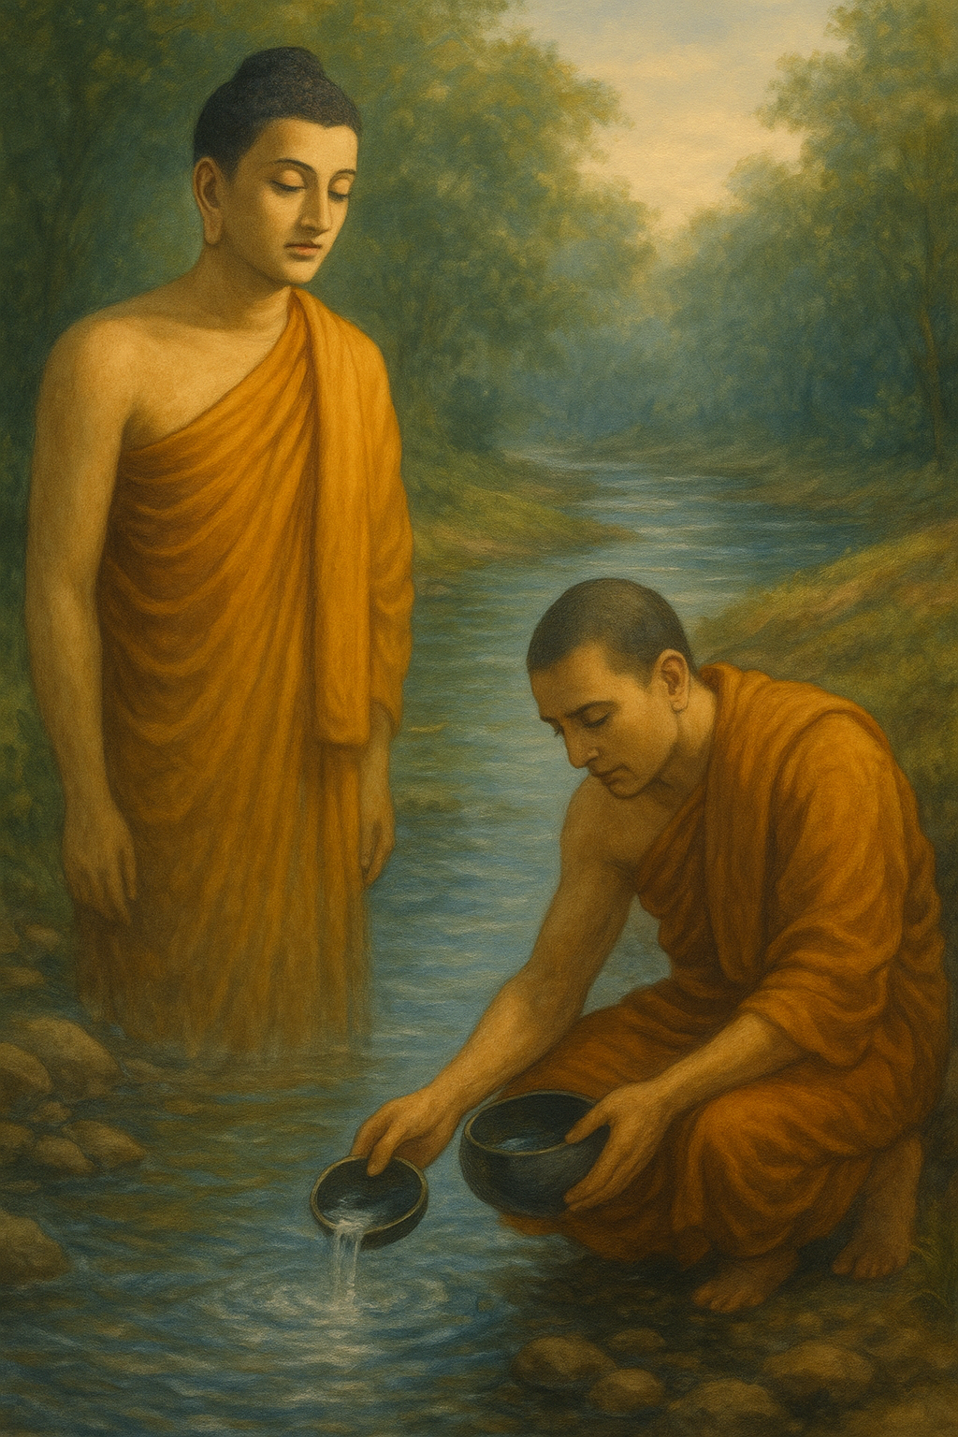

**Where Water Bows [28]**, *Thoughts of Venerable Ānanda*

## The Good Fortune of Pukkusa the Malla

At that time, Pukkusa the Malla—a sakyan and a follower of Āḷāra Kālāma’s teaching—was traveling along the highway from Kusinārā to Pāvā. As he journeyed, he beheld a serene and noble sight: the Blessed One seated peacefully beneath a tree near the banks of the River Kakutthā. Drawn by the calm and majestic presence of the Buddha, Pukkusa approached, respectfully saluted him, and sat down to one side.

Then, with admiration, he said:

“It is truly wonderful, Lord. It is marvellous how calm and composed these noble wanderers are!”

To illustrate his point, Pukkusa recounted a memory of his teacher:

“Once, Lord, Āḷāra Kālāma was traveling along the main road. Turning aside, he sat beneath a nearby tree for his midday rest. Just then, five hundred carts rumbled past close by.

A man who had been walking behind the carts approached him and asked:  
‘Lord, did you not see those five hundred carts pass by?’  
‘No, friend, I did not.’  
‘Did you not hear them, Lord?’  
‘No, friend, I did not.’  
‘Were you asleep, then, Lord?’  
‘No, friend, I was not asleep.’  
‘Then, Lord, were you conscious?’  
‘Yes, friend.’

‘So, Lord, being both conscious and awake, you neither saw nor heard five hundred carts pass so close to you, even though your robe was covered in dust?’  
‘That is so, friend.’

The man was astonished and praised Āḷāra Kālāma’s extraordinary serenity, thinking:  
‘Truly marvellous! Though conscious and awake, such a one can remain undisturbed even amidst the thunder of five hundred passing carts!’”

The Blessed One, ever gentle and full of compassion, responded with a question:

“Well then, Pukkusa, what do you think? Which is more difficult to achieve: to remain conscious and awake and yet not see or hear five hundred carts passing nearby—or, while fully awake and alert, to neither see nor hear anything even when the sky pours down rain, lightning flashes, and thunder roars?”

Pukkusa replied earnestly:

“Lord, there is no comparison. Even hundreds of carts are nothing compared to a mighty storm. To remain unaffected by such a force of nature is far more difficult.”

Then the Blessed One shared his own experience:

“Once, Pukkusa, while I was staying at Ātumā on a threshing-floor, a great storm broke out. Rain poured down, lightning flashed, and thunder roared. In the midst of this storm, two— farmer and his brother—and four of their oxen were struck and killed.

A crowd gathered at the place where they had fallen. At that time, I had been walking mindfully just outside the shelter, pacing up and down.

One man from the crowd approached, saluted me, and stood to one side. I asked him:  
‘Friend, why have so many people gathered here?’  
He replied: ‘Lord, a great storm has come, and two farmers and four oxen have died. But you, Lord, where were you?’

‘I have been right here, friend,’ I said.  
‘Did you not see or hear the storm, Lord?’  
‘No, friend, I saw and heard nothing.’  
‘Were you asleep, Lord?’  
‘I was not asleep.’  
‘Then, Lord, were you conscious?’  
‘Yes, friend.’

And that man thought in amazement:  
‘How wonderful, how marvellous! This noble one is so serene that even in the midst of thunder and lightning, he neither sees nor hears a thing!’

He saluted me, walked around me respectfully, and departed.”

Hearing this, Pukkusa was deeply moved. With a heart full of reverence, he declared:

“Lord, I now cast aside my former admiration for Āḷāra Kālāma’s powers as though it were dust blown away by the wind or swept off by a rushing river.

Excellent, Lord! Excellent! Just as one might raise up what has been overturned, reveal the path to one who is lost, or bring a lamp into the darkness so those with eyes may see—so too has the Blessed One expounded the Dhamma in many ways.

I go for refuge to the Blessed One, to the Dhamma, and to the Sangha. May the Blessed One accept me as a lay follower, from this day onward, for as long as life shall last.”

Then the Blessed One inspired, instructed, and delighted Pukkusa the Malla with a profound discourse on the Dhamma.

Thus, Pukkusa had the rare and auspicious fortune to encounter the Blessed One on the final journey of his life. Though unaware that this would be his last meeting with the Buddha, he was deeply inspired and filled with faith. Out of reverence and devotion, he offered two exquisite golden robes to the Blessed One and paid homage before departing.

According to tradition, these were the final robes offered to the Buddha in his lifetime. In that moment of generosity and devotion, Pukkusa gathered immeasurable merit—through both listening to the Dhamma and making offerings to the Tathāgata. Surely, such acts bore fruit in this life and beyond.

## Proceeding Towards the River Kakutthā

Soon after Pukkusa had departed, the Venerable Ānanda arranged a set of golden robes upon the Blessed One’s body. Observing closely, he noticed something remarkable.

“*Wonderful, Lord! Marvellous indeed,” said Ānanda. “How clear and radiant the Lord’s skin appears—it shines even more brightly than the golden robes in which it is clothed!*”[29]

The Blessed One replied:  
“*Just so, Ānanda. There are two occasions when the Tathāgata’s skin appears especially clear and luminous. Which are they? One is the night on which the Tathāgata attains supreme enlightenment. The other is the night when the Tathāgata enters the element of Nibbāna without remainder at his final passing. On these two occasions, the skin of the Tathāgata becomes especially radiant”*

**“Tonight, Ānanda, in the last watch, in the Sāla grove of the Mallas near Kusinārā, between twin Sāla trees, the final passing of the Tathāgata will take place. And now, Ānanda, let us go to the River Kakutthā.”**

“Very good, Lord,” Ānanda replied.[30]

Then, having made known that his final passing would occur in the last watch of the night, the Blessed One, surrounded by a large assembly of monks, slowly proceeded toward the River Kakutthā.

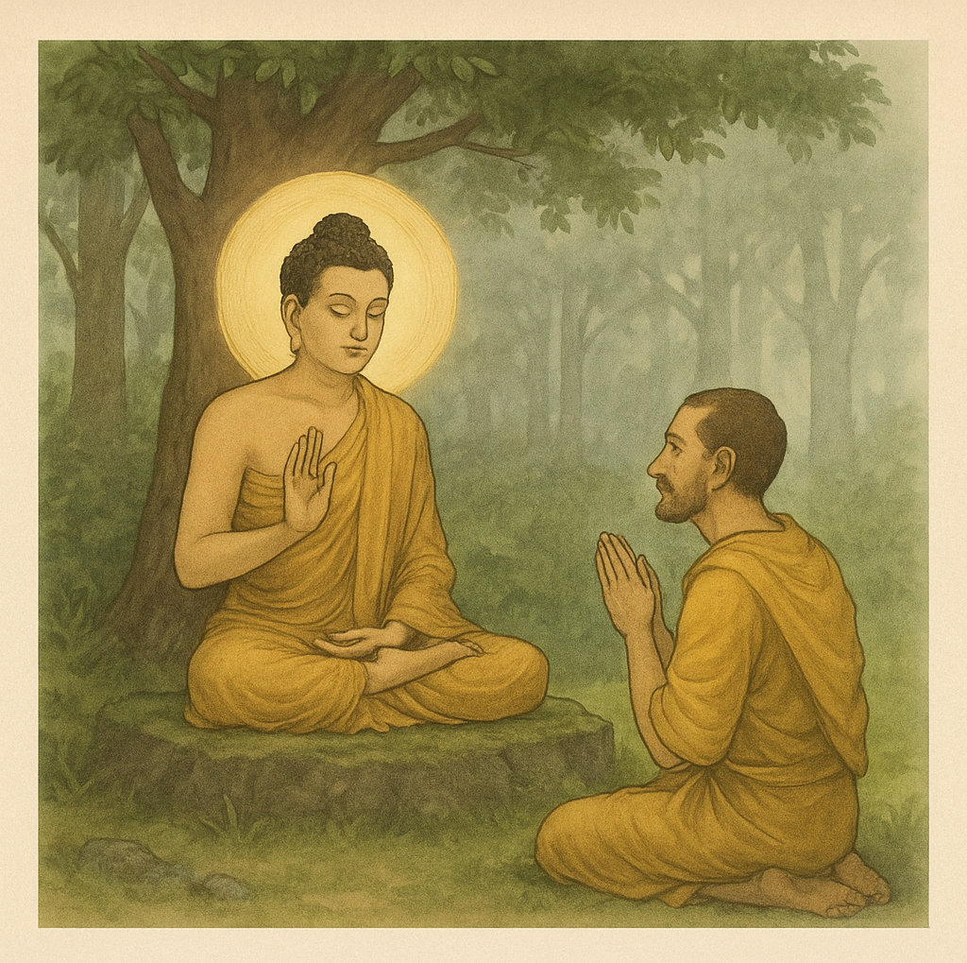

**Good Fortune of Pukkussa Malla [31]**

### Good Fortune of Pukkussa Malla

**Beneath a Tree by forest stream**

**Sits He who’s wakened from all dreams.**

**To Pukkuhsa the Blessed One speaks:**

**No Outer sound can shake the soul**

**Of one who’s strong within and whole.**

**Now refuge in the Triple Gem**

**Pukkusa takes —his heart at peace.**

**Two golden robes were Pukkusa’s offering:**

**Brighter shone the Teacher’s body than its dress.**

### Where is the River Kakutthā?

Ancient tradition holds that the River Kakutthā flowed southward near Kusinārā, within the realm of the Malla kingdom. While its precise location remains uncertain, some modern scholars identify it with the present-day *Khanua River*, a tributary of the Little Gandak River in Uttar Pradesh, India. This modest river, quietly flowing through the Kushinagar district, may well be the same stream mentioned in the sacred texts as the place where the Blessed One bathed before his final moments. According to local sources, the Khanua River continues to shape the region’s landscape, even occasionally causing floods—yet it also carries a serene spiritual history beneath its waters.[32]

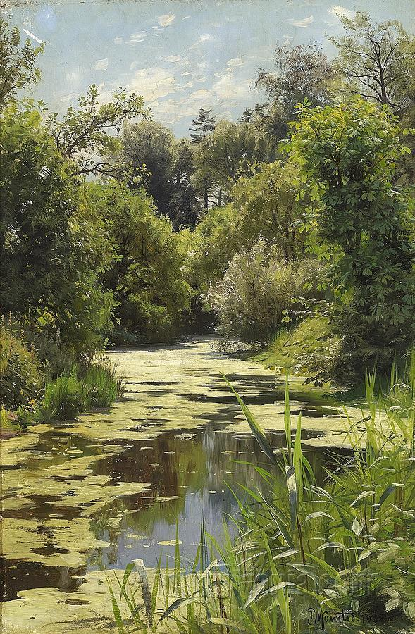

**A Stream in a Forest- Perhaps -River Kakutthā flowed like this [33]**

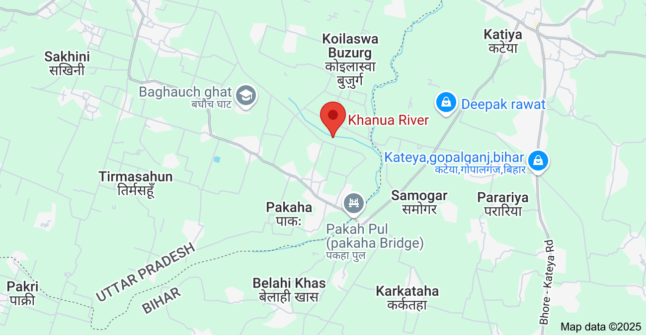

**Location of the present day Khanua River (believed to be ancient River Kakutthā) in Kushinagar District of UP.[34]**

### The Final Bath in the Kakutthā River

The scriptures beautifully recount the scene:[35]

*The Buddha, having gone to Kakutthā, the river  
With its clear, bright, and pleasant waters,  
Therein the Teacher plunged his weary body—  
The Tathāgata, peerless in all the world,  
Surrounded by the Sangha, whose head he was.[36]*

After bathing in the cool, refreshing waters, the Blessed One, the Lord and Preserver of the Dhamma, made his way to the nearby Mango Grove. There, he addressed the devoted monk Cunda: **“**On a fourfold robe I shall lie down.”

Cunda, moved by reverence, spread the robe as requested. The Teacher then laid down His weary limbs to rest, while Cunda kept quiet vigil beside him.

### Reflections

We may wonder: Could that gentle river—untouched by time, still flowing through the heartland of India—be quietly remembering the moment it bore the touch of the Blessed One? The same river whose waters once soothed the weary body of the Great Sage before his final crossing?

Today, the devout may feel drawn to seek out this humble stream—not for ritual bathing or purification (as the Blessed One himself reminded us in the *Vatthūpama Sutta*, MN:7, that no water can wash away unwholesome deeds)—but to stand silently on its banks, and remember. To remember that once, long ago, the Tathāgata stood by this water, serene and luminous, ready to pass into the unconditioned. The river may be hidden, but its story still flows.

**Citation from Vatthūpama Sutta ( MN:7)**

What can the Sundarikā bring to pass?

What the Payāga? What the Bāhukā?

They cannot purify an evil-doer,

A man who has done cruel and brutal deeds.

One pure in heart has evermore

The Feast of Spring, the Holy Day;

One fair in act, one pure in heart

Brings his virtue to perfection.

It is here, brahmin, that you should bathe,

To make yourself a refuge for all beings.

And if you speak no falsehood

Nor work harm for living beings,

Nor take what is offered not,

With faith and free from avarice,

What need for you to go to Gayā?

For any well will be your Gayā.”

## Final River Crossing

Throughout his long ministry, the Blessed One crossed countless rivers—whether wide or narrow—not merely to traverse the land, but to reach those in need. With great compassion, he journeyed tirelessly for the sake and welfare of all beings, showing them the way across the ocean of saṃsāra to the other shore: the end of suffering.

For forty-five years, the Tathāgata wandered from village to village, forest to city, uplifting beings—humans and devas alike—guiding them to see the truth of existence and to free themselves from the bondage of birth, aging, sickness, and death. Each river he crossed was not just a physical passage, but a symbol of the spiritual crossing he offered to others.

And now, on this final journey, the Blessed One came to the Hiraññavatī River, surrounded by a great assembly of monks. With calm and dignity, he crossed it—his last river crossing—and entered the *Sāla Grove of the Mallas*, near the ancient city of Kusinārā**. See** the image below: [37]

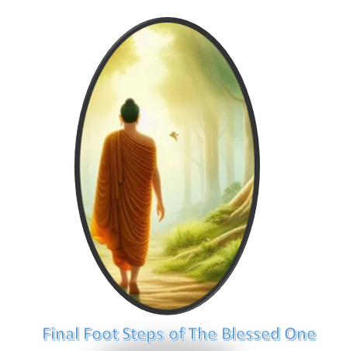

### The Hiraññavatī River

According to tradition, the *Hiraññavatī* flowed near Kusinārā, and on its bank stood the *Upavattana Sālavana*—the grove of twin Sāla trees belonging to the Mallas—where the Blessed One would attain Parinibbāna.

Scholars have identified this river with the present-day *Little Gandak*, which flows through the Gorakhpur district of Uttar Pradesh, eventually merging with the Gogra River. [38] Although its exact ancient course is difficult to trace today, what remains clear through scriptures and sacred memory is this: it was near this gentle river, in the peaceful grove beyond its waters, that the Teacher laid down his final burden.

### Reflections

This river, like so many before it, became a witness to the sacred journey of the Buddha. But unlike those before, this crossing was not to reach a new village or deliver a new discourse. This was the final crossing—quiet, serene, and full of meaning. Here, the Great Sage would complete the journey of a thousand paths, not to begin again, but to enter the Unconditioned, the Deathless, the Nibbāna beyond all becoming.

For us, these rivers and groves—whether their modern names are known or lost—remain as landmarks in the heart. Each step the Blessed One took reminds us of his boundless compassion, his tireless effort to awaken the world, and his gentle, unwavering resolve to guide all beings to peace.

With this, we bring this section to a close.  
In the next section (19.5), we will reflect on the sacred and solemn moment of the Great Parinibbāna of the Blessed One.

### End Note: Section 19-4

1. According to Aṭṭhakanāgara Sutta (MN:52) after the final passing of the Buddha Venerable Ãnanda has lived in that village.
2. DN:16
3. Source: Source: <https://www.craiyon.com/image/vSj1kzhFR7Wa-1VqADAZGg>
4. Thag:16:892.
5. DN:16
6. Source: “Last Days of the Buddha”: by Sister Vajirā & Francis Story, BPS: 67/68.Wheel
7. DN:16.
8. Dhp:31 & 32: Dhammapada translated by Ānandajoti Bhikkhu (2nd edition, November 2017): <https://ancient-buddhist-texts.net/Texts-and-Translations/Dhammapada/index.htm>
9. Based on the calendar given in Wikipedia: <https://en.wikipedia.org/wiki/Buddhist_calendar>
10. Google Maps
11. DN:16
12. Google Maps
13. DN:16.
14. DN:16 and the same discourse was also at AN4:180.
15. DN:16
16. Source: <https://www.facebook.com/p/Fazilnagar-Uttar-Pradesh-274401-100071531614032/>
17. Source: Wikipedia
18. Google map
19. Source: <https://en.wikipedia.org/wiki/P%C4%81v%C4%81>
20. Source: <https://www.buddhistdoor.com/OldWeb/bdoor/archive/budd_story/blpg43.htm>
21. Sūkara-maddava: a controversial term which has therefore been left untranslated. Sūkara = pig; maddava = soft, tender, delicate. Hence two alternative renderings of the compound are possible: (1) the tender parts of a pig or boar; (2) what is enjoyed by pigs and boars. In the latter meaning, the term has been thought to refer to a mushroom or truffle, or a yam or tuber. K.E. Neumann, in the preface to his German translation of the Majjhima Nikāya, quotes from an Indian compendium of medicinal plants, the Rājanigṇṭu, several plants beginning with sūkara: source: note:38: Last Days of the Buddha”: by Sister Vajirā & Francis Story, BPS: 67/68.Wheel.
22. It says this is the way Venerable Ãnanda reported this at the first council, see: DN: Note: 419.
23. DN:17: (Mahāsudassana Sutta)
24. DN:16
25. Ibid. * also see: “Last Days of the Buddha: by Sister Vajirā & Francis Story, BPS: 67/68.Wheel
26. Ibid.
27. The moving poem created by a very dear friend who supported this publication with kindness and devotion.
28. Image created by AI.
29. DN:16
30. Ibid.
31. Image created by AI. The poem written by a very dear friend.
32. Source: 1. [https://en.wikipedia.org/wiki/Kushinagar](https://en.wikipedia.org/wiki/Kushinagar%202)

    Source 2. <https://www.cgwb.gov.in/old_website/District_Profile/UP/Kushi%20Nagar.pdf>
33. Source: <https://www.paintingmania.com/stream-forest-autumn-264_53134.html>
34. Google Maps.
35. DN:16
36. Ibid.
37. Source: <https://creativetribals.com/buddha-purnima/#google_vignette>
38. Source: <https://www.wisdomlib.org/definition/hirannavati>